Tommy Huynh

CIS 4296 1 Homework 1

1/14/2020

**Part 1 : Building Your Team Quiz Questions & Answers**

🡪 Showing vulnerability as a team leader is an asset as it will help your teammates feel **empathy** towards you.

🡪 In the norming stage, the leader’s role evolves from a directive role to one that is more of **a supportive role**.

🡪 The “Forming Stage” is essentially done when everyone knows each other’s names & has their contact info. **FALSE**

🡪 What is NOT a benefit of online team gaming experience to your team members?

**They recognize the importance of keeping score**.

🡪 For cross-functional teams, the topics of conflict and conflict resolution **should be dealt with early in the team's formation**.

🡪 In the Plus/Delta evaluation method, what does Delta refer to?

**what could be made better**

🡪 When planning on how to prevent important data from being lost or stolen, which of the following is a task? **Buy a shredder.**

🡪 When preparing a meeting agenda, make sure **to solicit input from those who will attend as to what they would like to have included.**

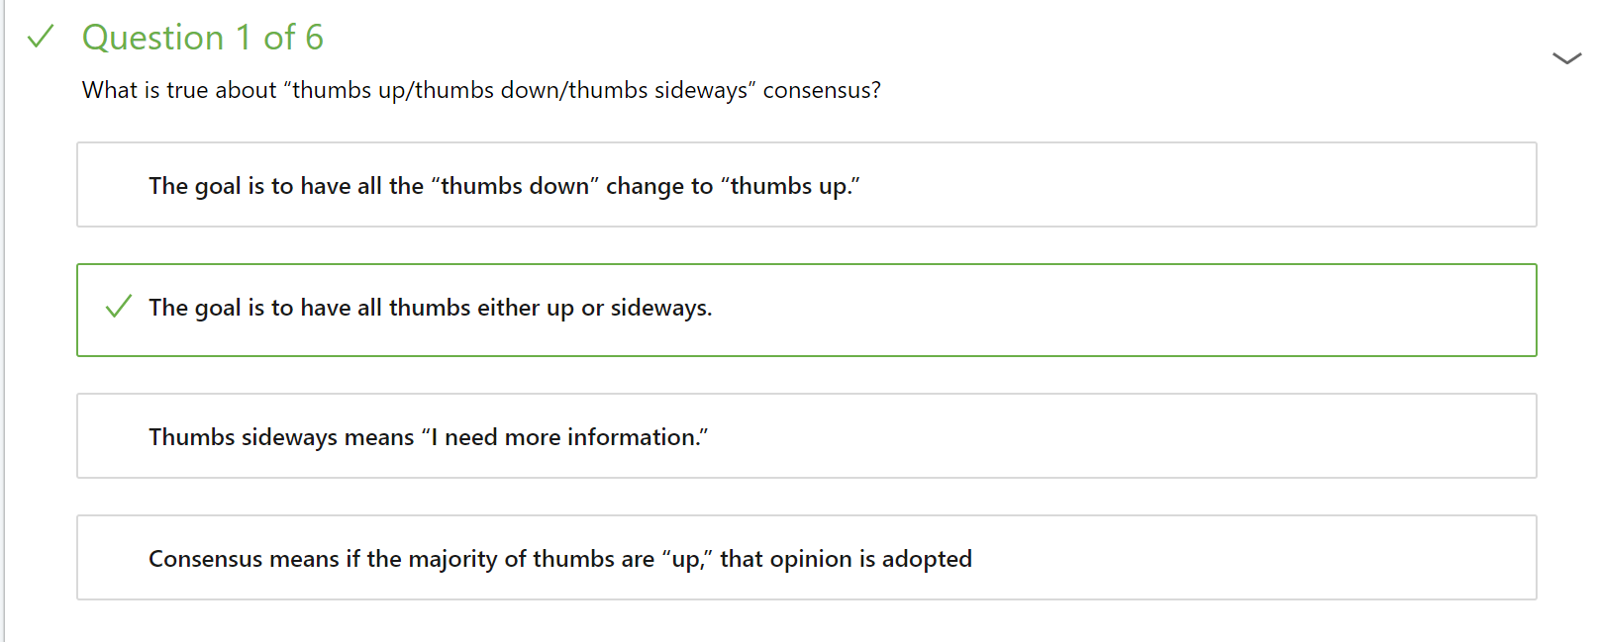

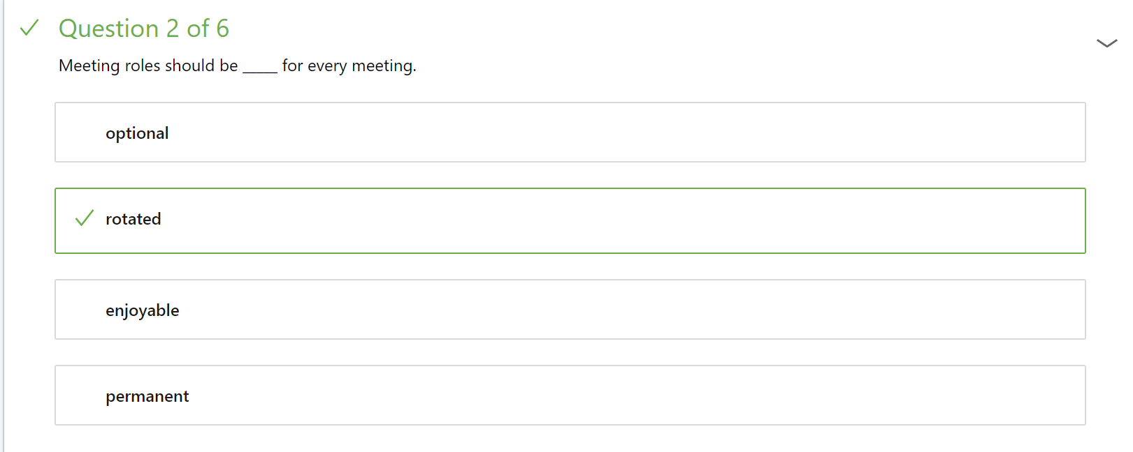

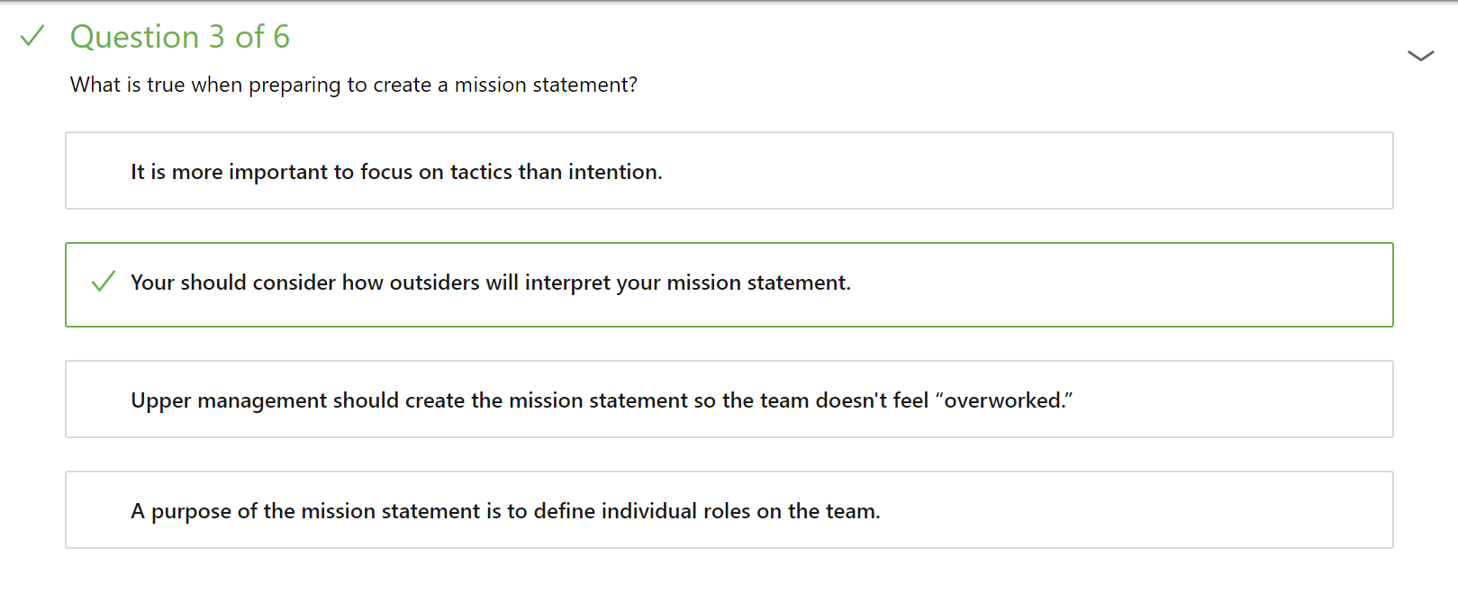

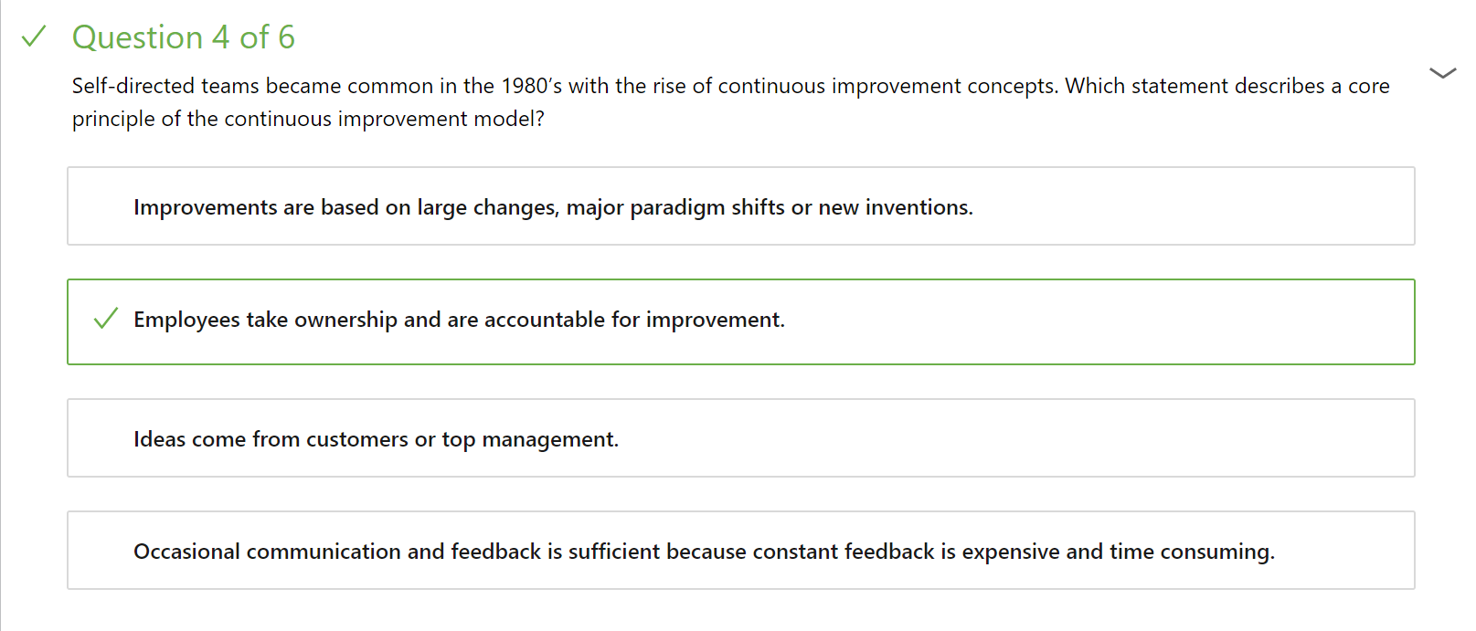

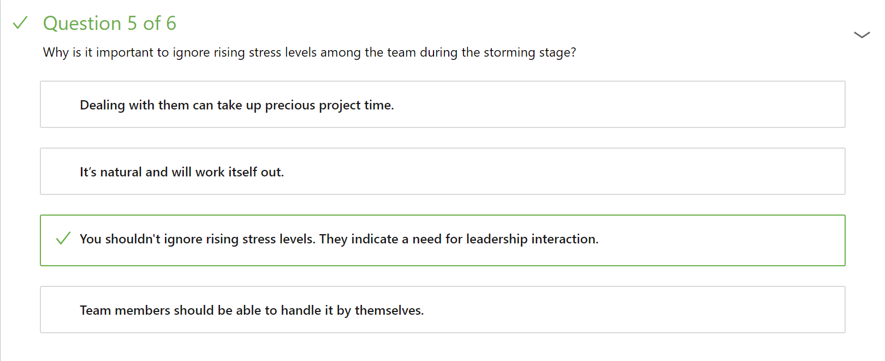

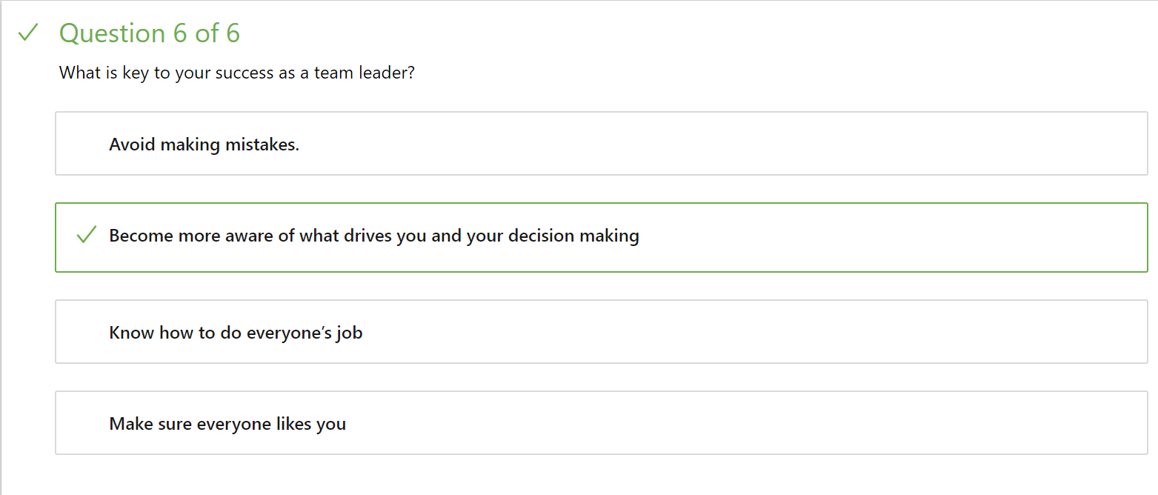

**Behavioral Questions (STAR FORMAT)**

**1. What role do you normally take on a team? Why?**

Last semester, I was paired with a classmate and we had to create a system where merchants could register their customers similarly to Grubhub. I found that my partner was very impatient and was in a rush to start coding. I realized things would get unorganized very quickly, so I suggested that we plan first. I usually tend to be the planner in the group, so I took charge in that role and incorporated any ideas my partner had into our planning. I like to have everything structured so building an application will organized. Although, we did not finish all the requirements due to time issues like most teams, I would like to say it was a lot better than if we didn’t plan at all.

**2. Was there ever a time when you were part of a team and the people didn’t get along? What happened? What did you do?**

In my Chinese class in high school, we had to get into groups and perform a skit. The issue was that two of the members wanted the same role in the skit. I tried not to get caught up too much into the dispute, but I suggested that since there was going to be a part 2, they could switch roles for next part. They seemed to like the idea but then fought over who would get the desired role first. They then decided to play rock-paper-scissors to determine that. Both were happy with the results and ended with a good project.

**3. Can you describe a time when a team member wasn’t doing their work? What did you do?**

In one of my classes, the professor assigned a project to create a presentation in a group. One of our members didn’t seem to be doing anything at all. Another member of our team suggested we tell the professor and see what happens. I wanted to give him a chance though and decided to reach out to him. He said he had family issues and didn’t know what was going on in the class. Although I felt bad for him, I believe he was still responsible for his work. I offered to meet with him and give him help if he needed it. With that, he was able to contribute to the presentation instead of possibly being kicked from the group.

**Part 2**

1. Rhythm ensures that a meeting is possible and goes according to plan. Clients can be very busy so scheduling around that can be tricky. Meetings during busy hours should be avoided such as when clients have other things to do that day. It would also be helpful for everybody to use the same calendar application such as google calendars or outlook. This ensures that everybody is getting reminders that are sent out. Leaders should send out reminders prior to the each meeting.

2. The value of taking meetings is to get everybody on the same page before and after the meeting. A designated notetaker will cover information regarding actions. The notetaker at the end of the meeting will remind everyone of their commitments. An email should be sent out to everyone in the meeting reminding everyone what the meeting covered or if anyone missed the meeting. The value after the meeting is the ability to take note of commitments that you or other people made. If anything is missed, send an email back to the notetaker so they can send it to out to everybody else.

3. The meeting leader should ensure that principles such as agenda, time, and purpose are met. The meeting should start and end in the expected timeframe. Also, the leader should make sure the meeting doesn’t get off topic of the agenda. Additionally, the meeting should have a defined set purpose. We can select our team leader by rotation. This ensures everything gets the opportunity to play the leader role and develop leadership skills. I believe this will work since it is fair for everyone and is a good opportunity that nobody should miss.

4. Every meeting should include action items, tasks, and commitments. At the end of the meeting, the notetaker should have a list of commitments and actions that people have agreed to complete. After the meeting, the leader should set a reminder on their calendar of when people have committed to a certain item being done. The leader can then follow up asking if they completed it and if not, what obstacles got in the way. Additionally, if members complete the task early, they can send out an email stating so.

**Part 3 : Walk Only Petition**

1. How does the current system work?

a. What parts are automated?

b. What parts are manual?

2. What are the current problems in the system?

a. Which is the most critical?

3. Who is the primary users?

a. Can juniors/sophomores/freshmen access the system?

b. What can an admin do that a regular user cannot?

4. How do you want data stored?

a. Do you want a database?

b. What sensitive information are we storing?

5. When is the service available?

a. When in the semester is the service start and end?

b. Is the service going to be available 24/7 Monday to Fri?